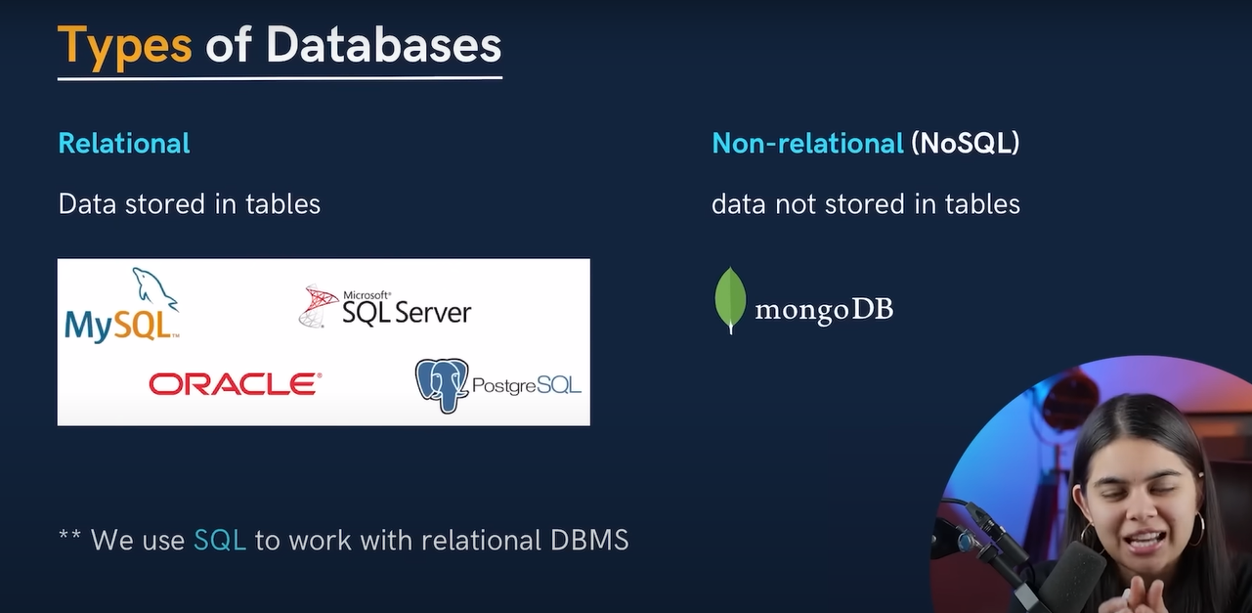

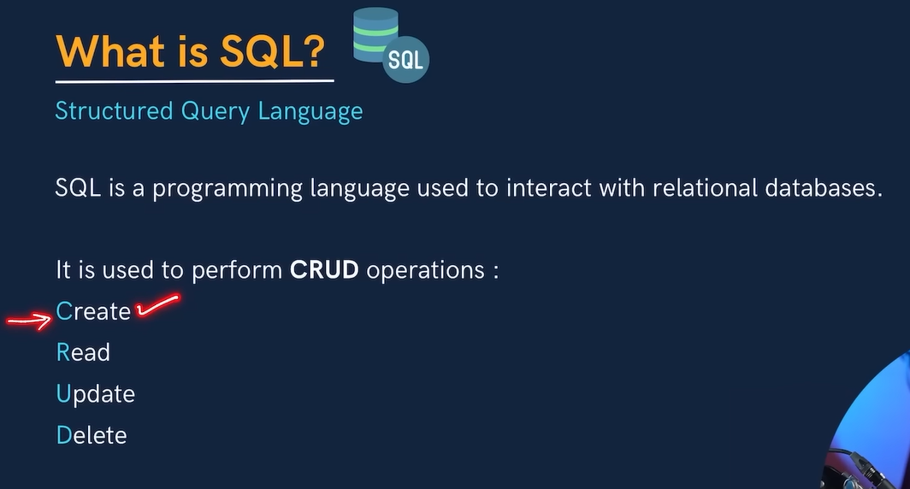

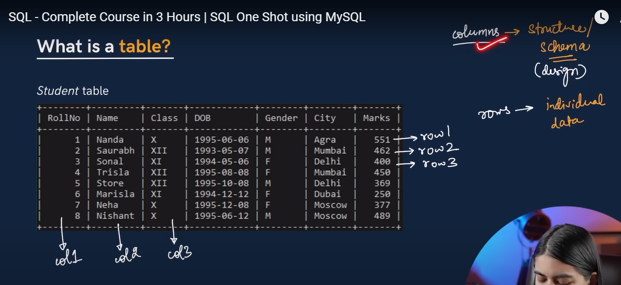

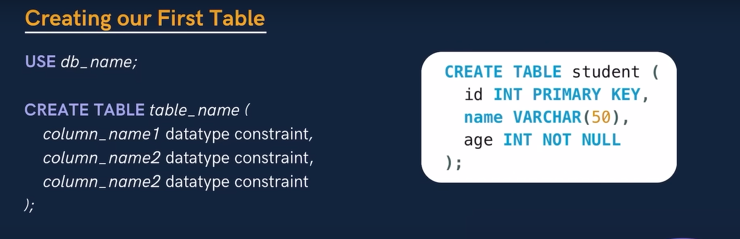

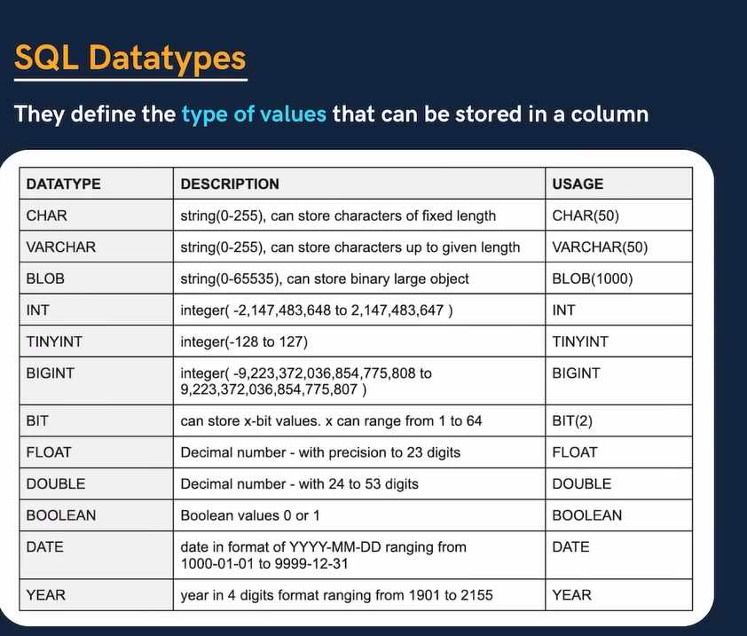

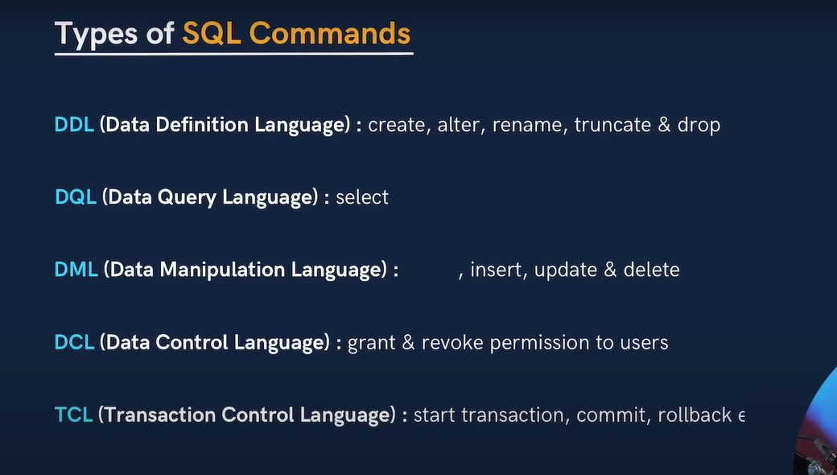

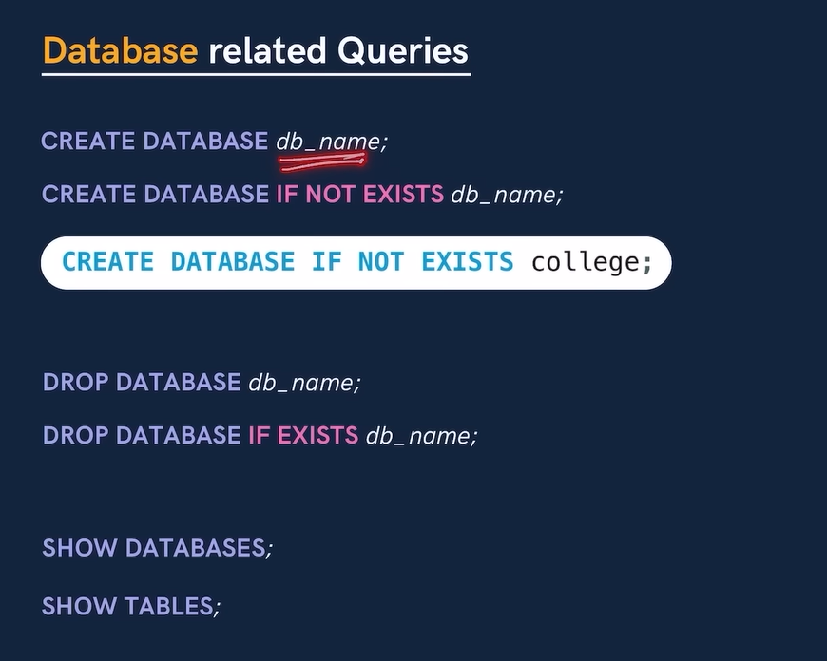

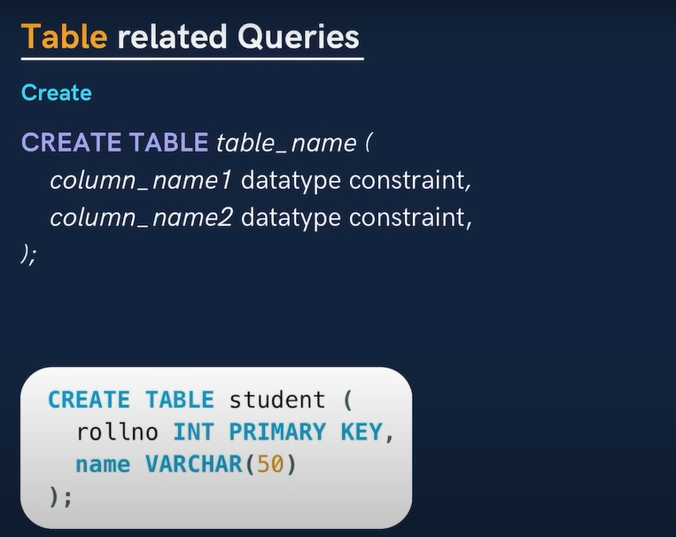

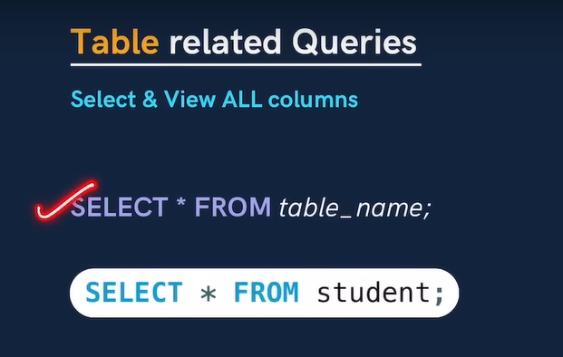

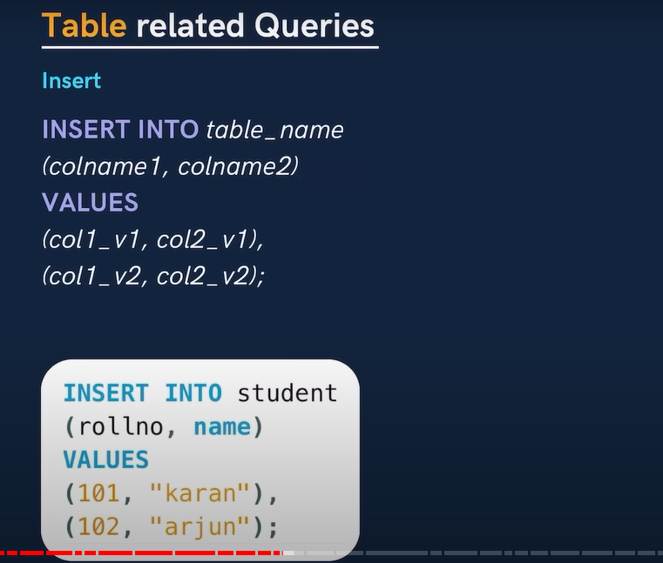

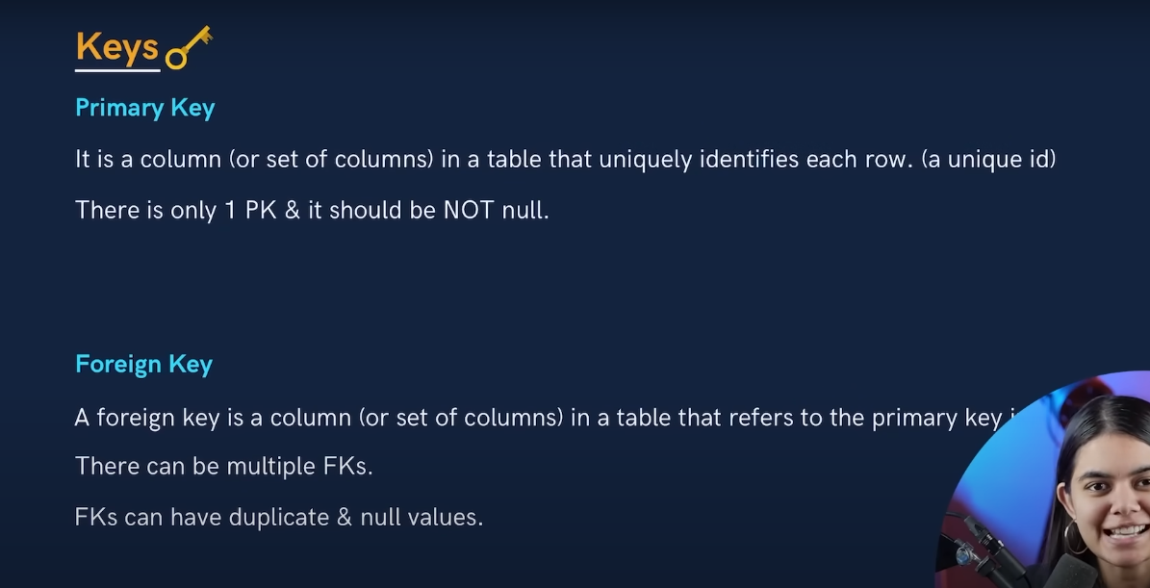

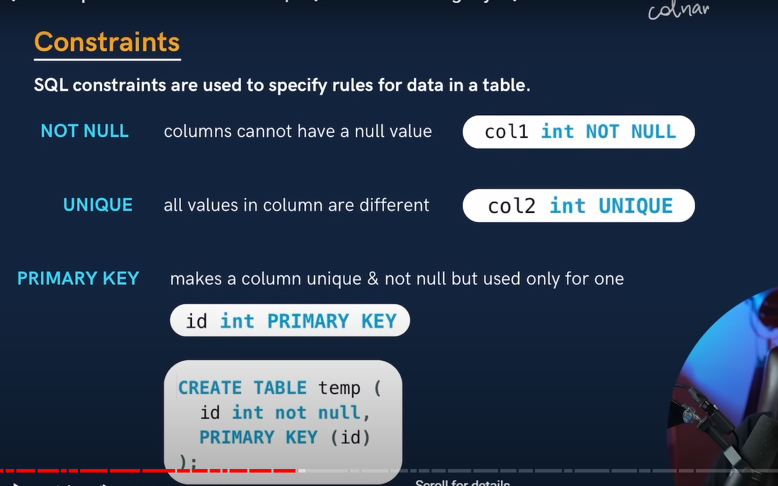

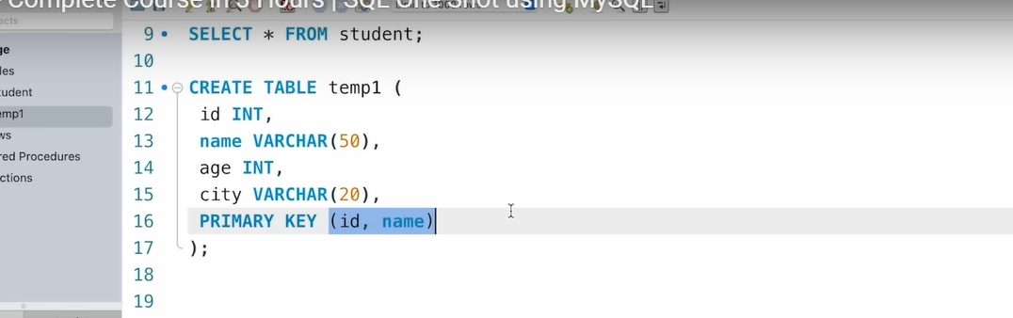

* Above sc primary key is combination of id and name so id can be duplicate, name can be duplicate, but combination of id and name can’t be duplicate.
* Example below
* Where we can check id is duplicate , name is also duplicate but combination of id and name is not duplicate

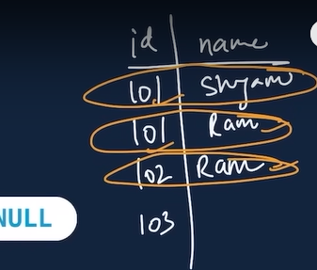

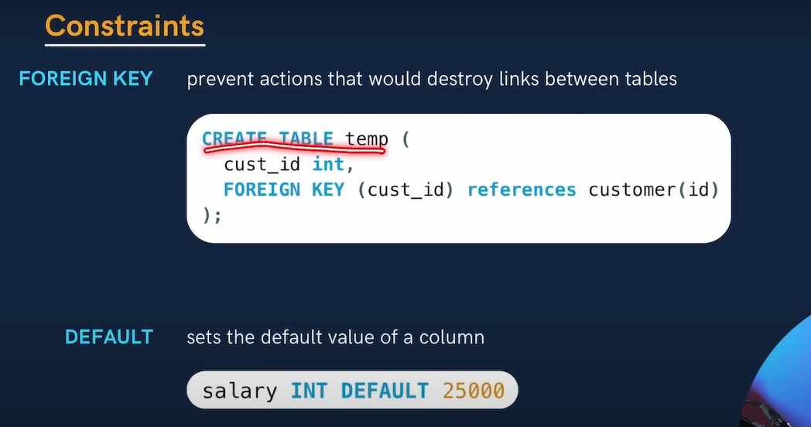

* For above sc we declare cust_id as FK because it is already PK in customer table (id)

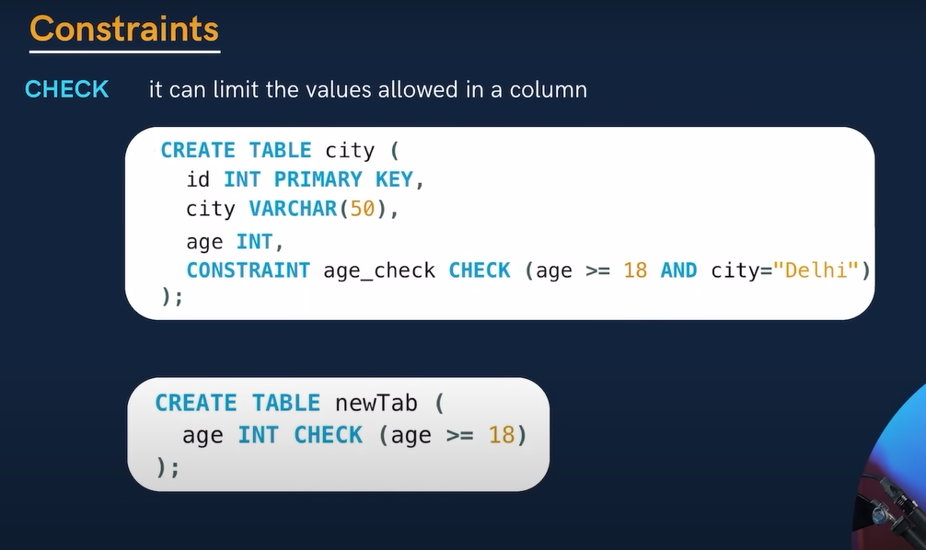

* Above CONSTRAINT age_check🡪age_check is just name we can give any name instead of that.

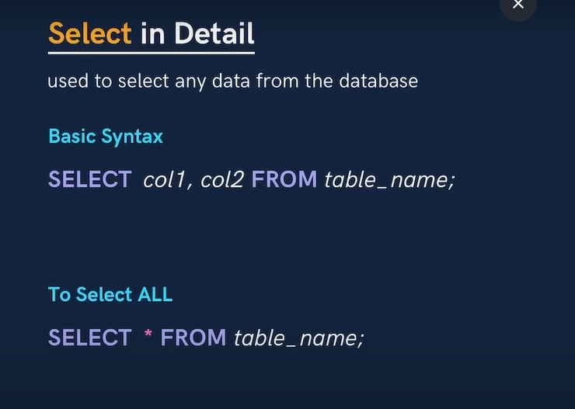

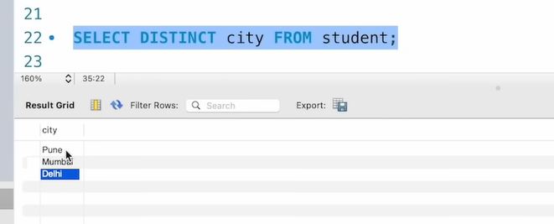

* Here we use DISYINCT keyword to get unique cityname from city coloum.
* It will provide unique city and it will avoid duplicate city name.

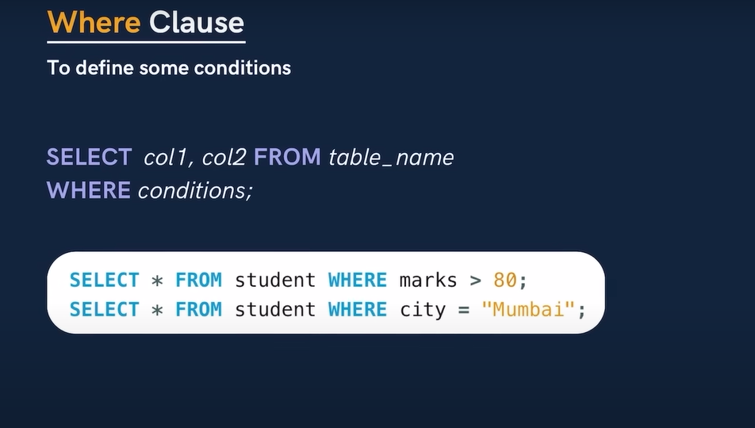

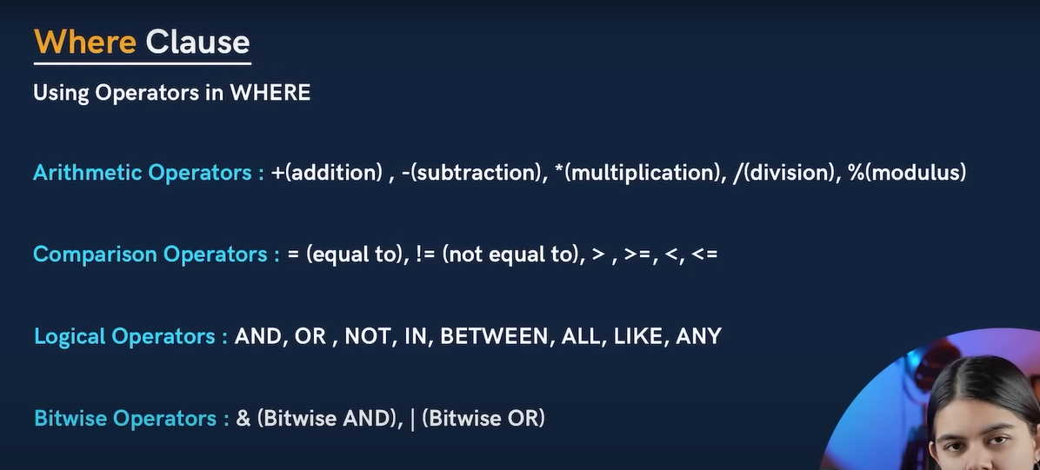

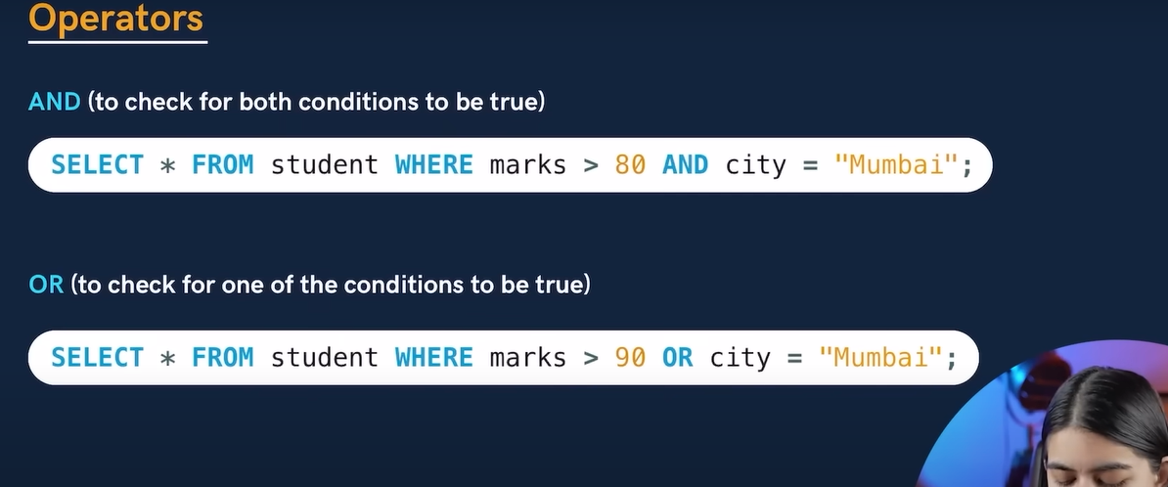

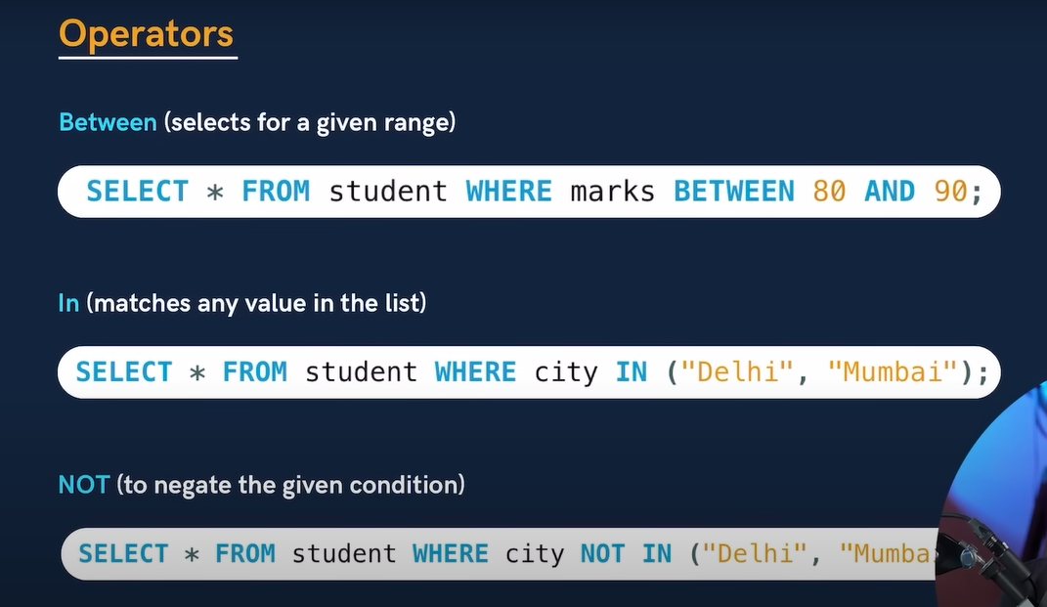

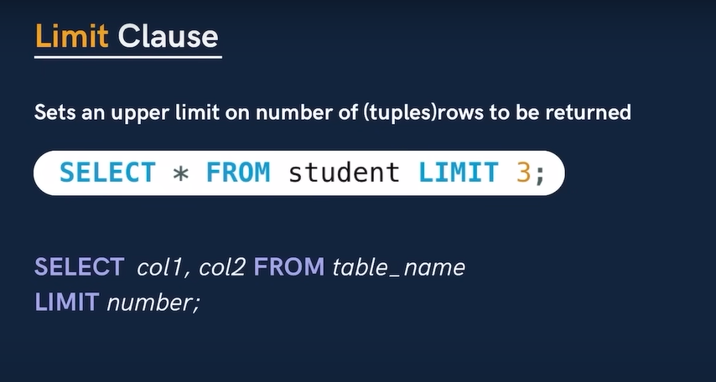

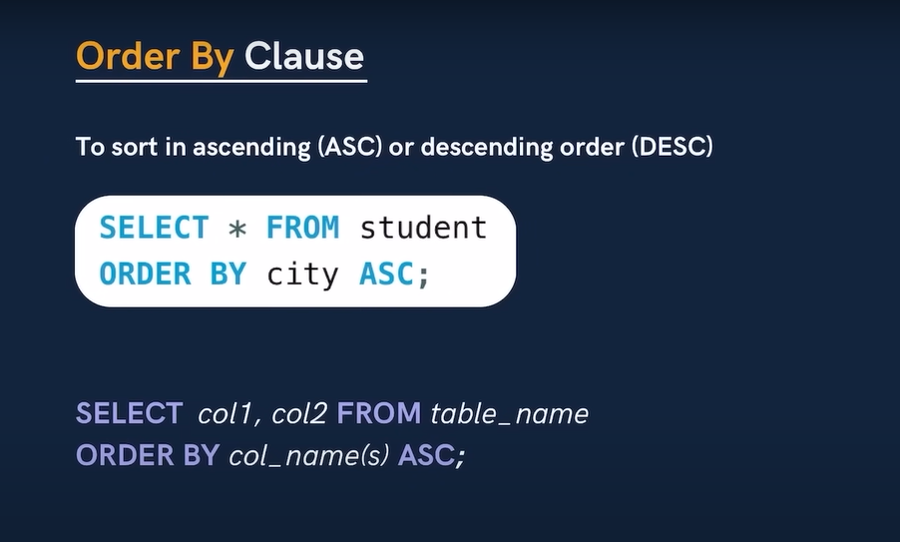

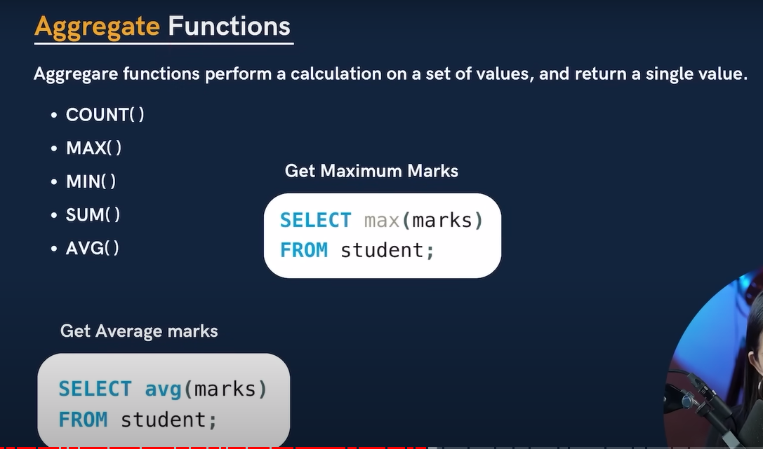

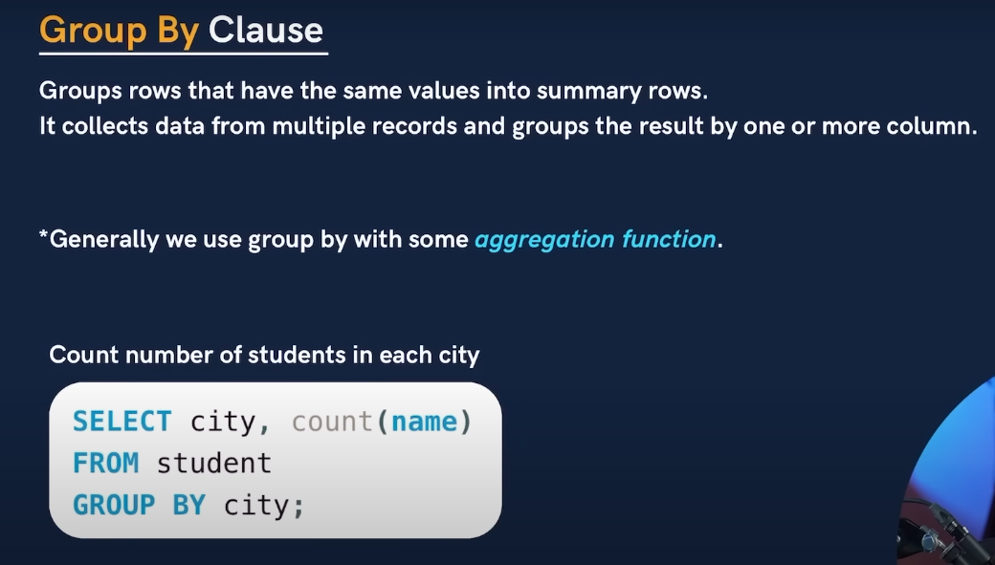

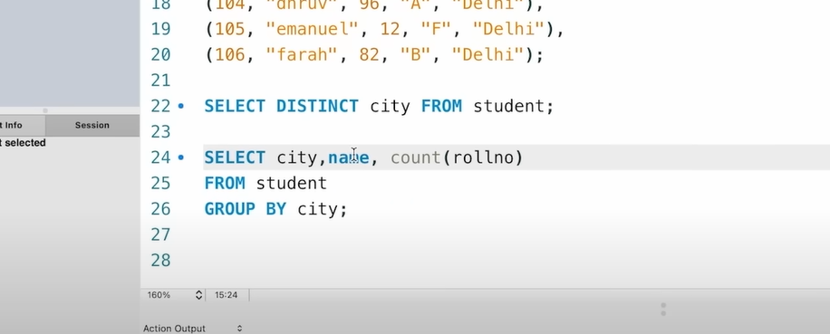

* Above whatever column we declare without aggregate same coloum name should be there in order by
* Example:
* Select city,name,makrs , count(roll n0) from student group by city,makrs,name;

Else will get sql error.

* On which Coolum we can to create group need to use that Coolum name in group by.

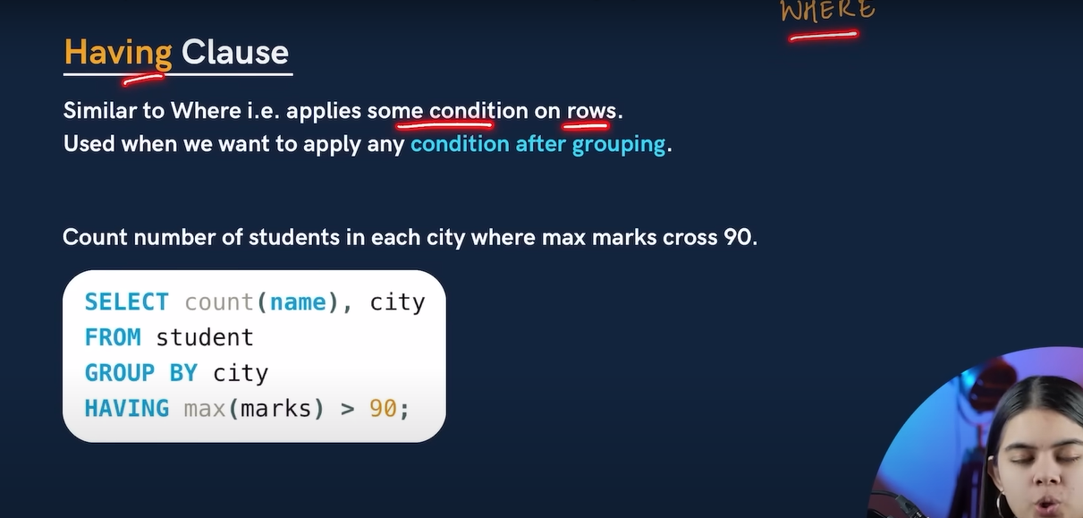

* Where clause used to apply condition on rows and having clause used when need to apply condition on groups.

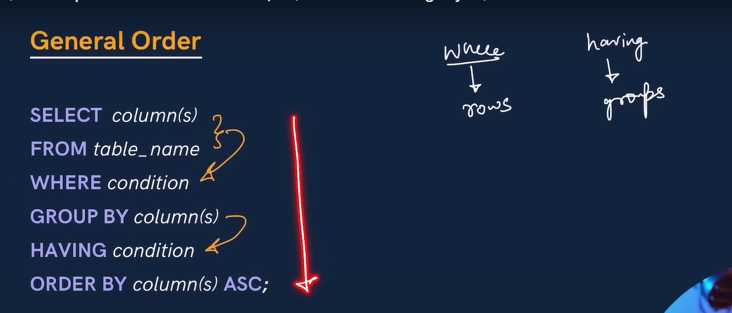

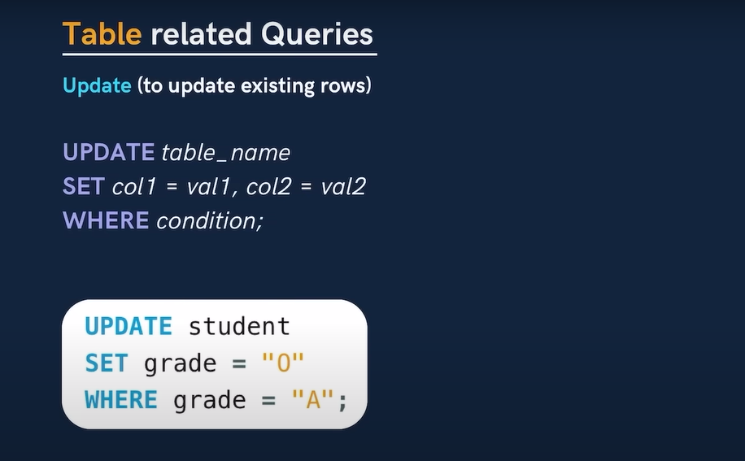

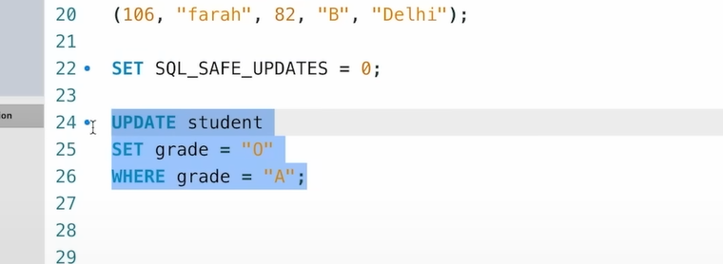

* Need to off safe mode because when safe mode is on we can’t modify or update table so we need to make safe mode off.(0🡪off and 1🡪on).

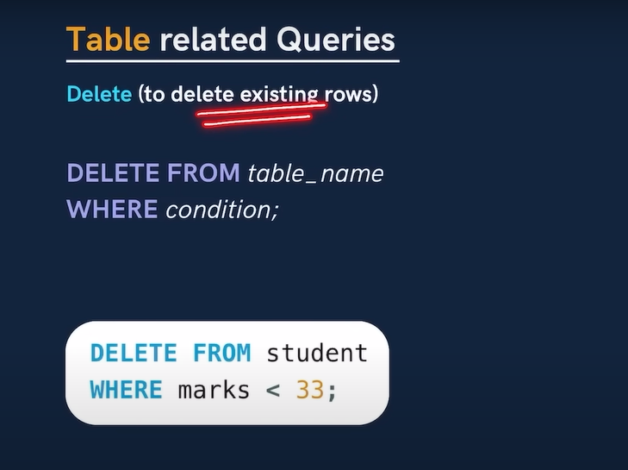

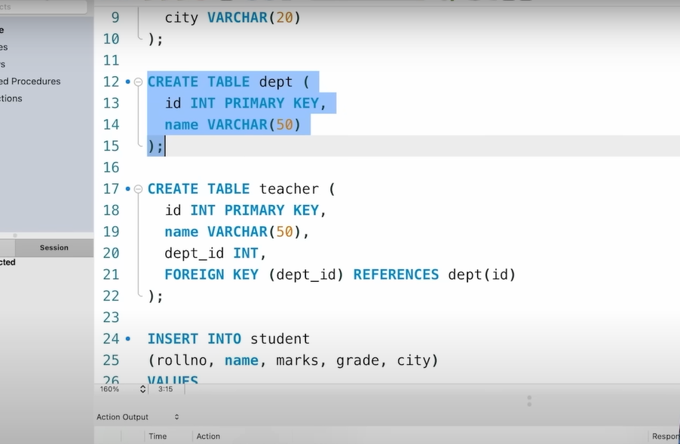

* We mentioned dept_id as foreign key with reference to dept which having primary key as id
* So we wrote foreign key (dept_id) references dept(id).

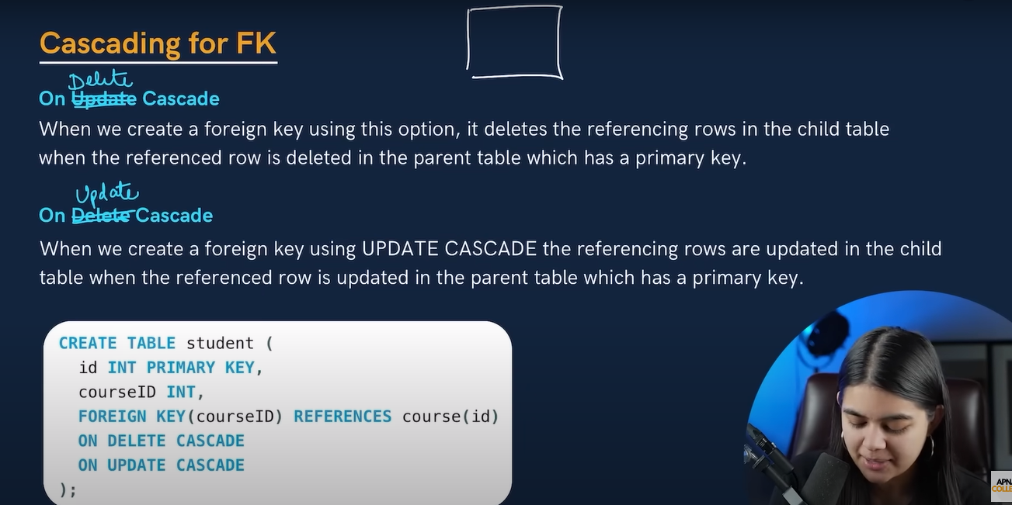

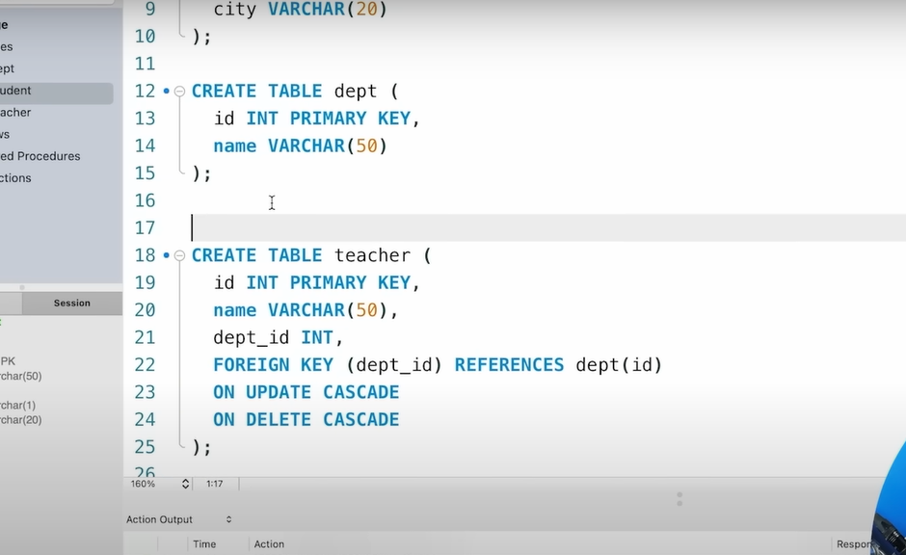

* If we want whatever changes happen in parent table and same value should be reflected in foreign key then we should write on update/delete cascade.
* But in some cases, if we don’t want to update/delete that value in child table then no need to write on update/delete cascade.

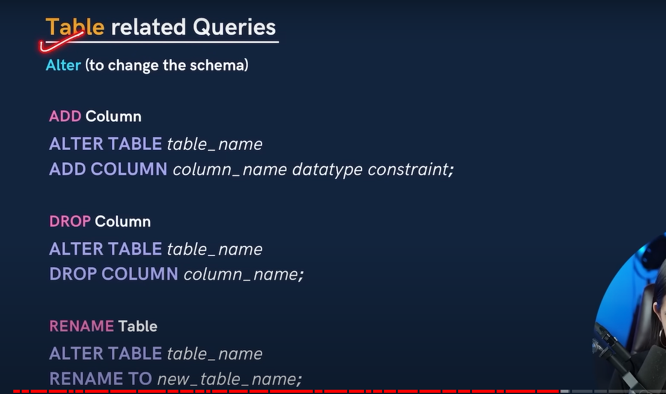

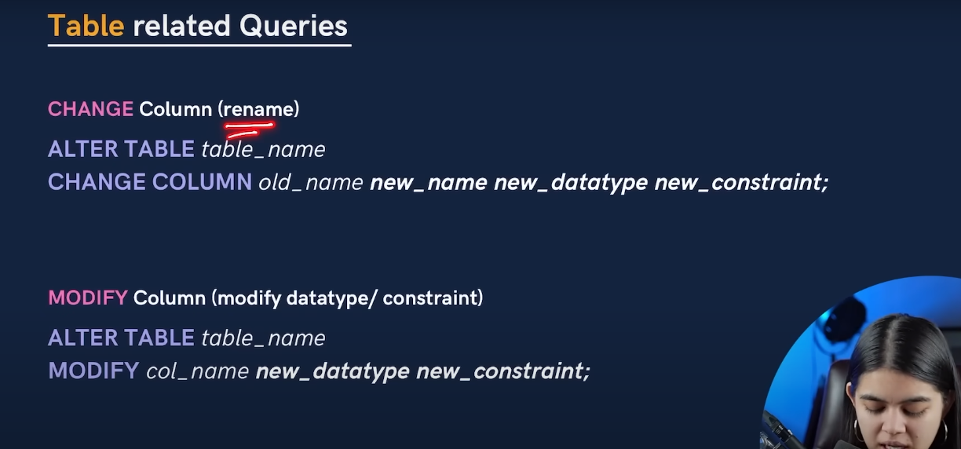

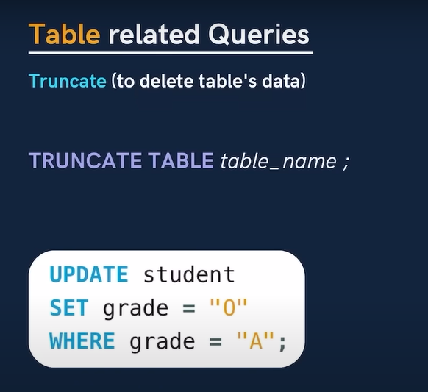

* Truncate is used to delete all tables data.
* **Drop will delete all table but truncate will delete only table data. Using truncate table will be exit and we can add data to it.**

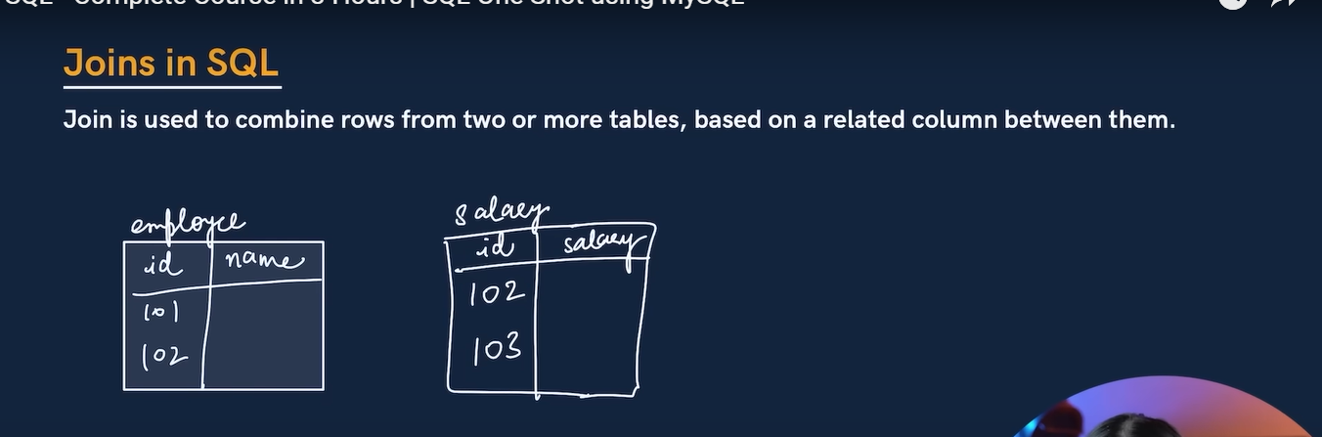

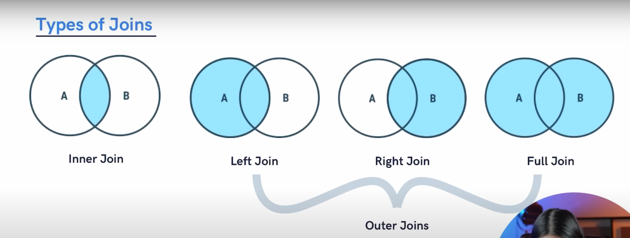

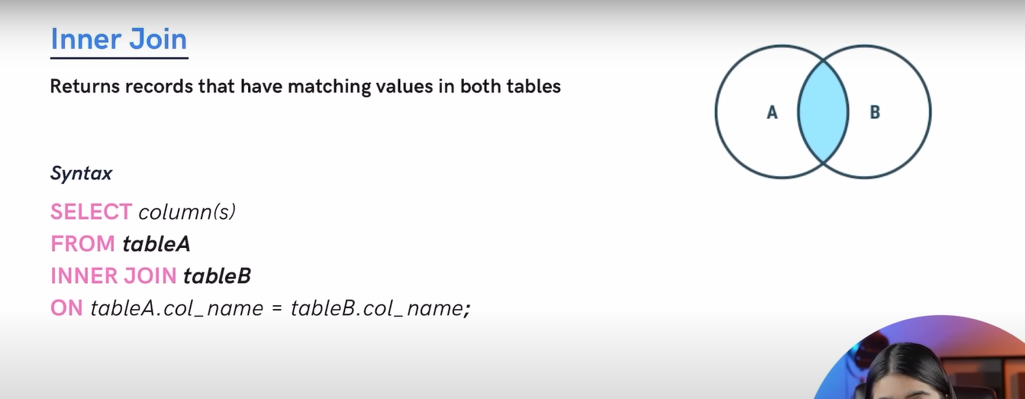

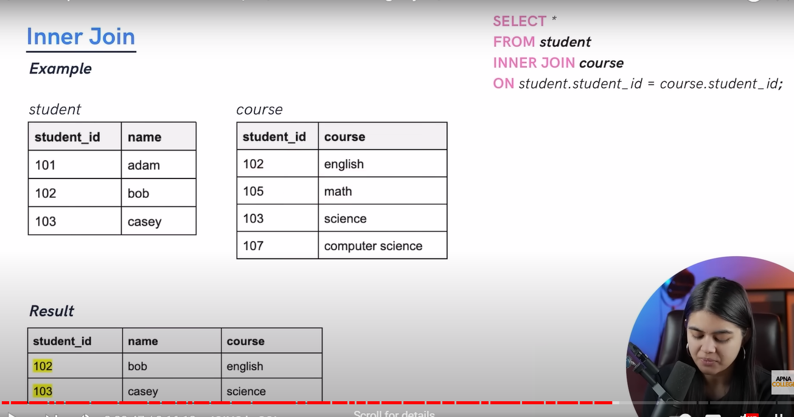

NOTE: it is not necessary that both column should be same to perform inner join.

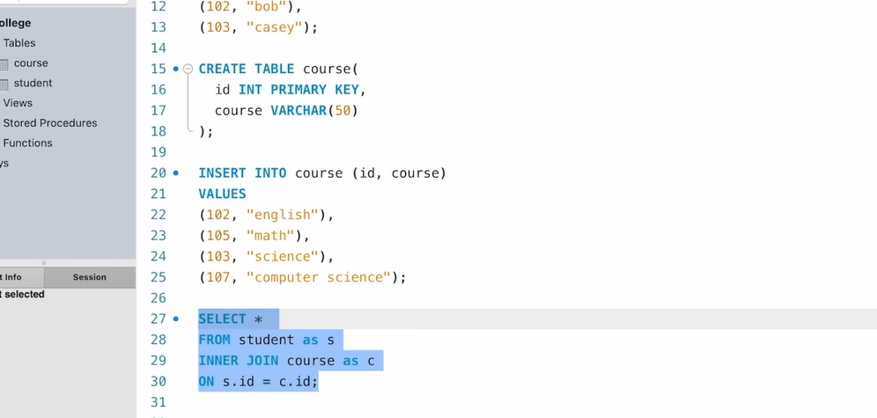

* NOTE: Alias 🡪where we can give alternate name to the table if table name big like above example.

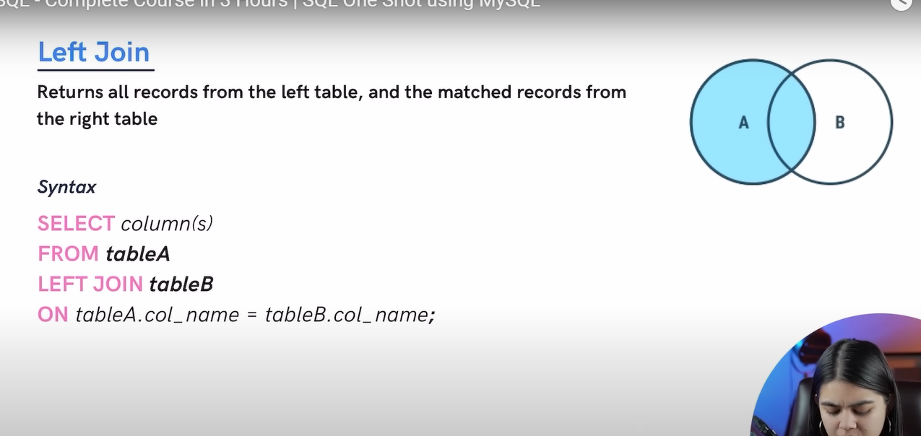

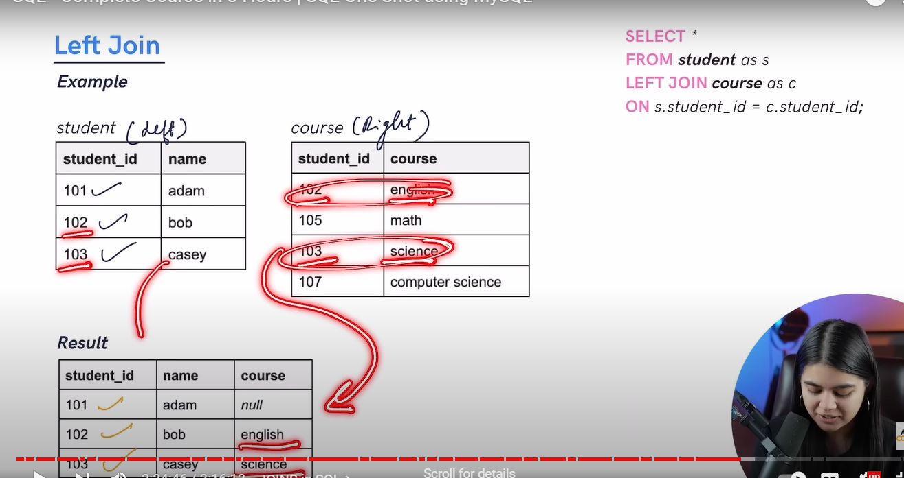

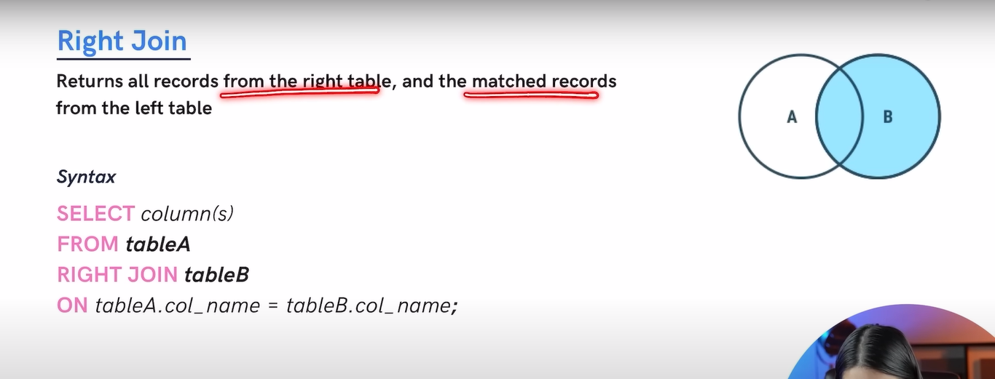

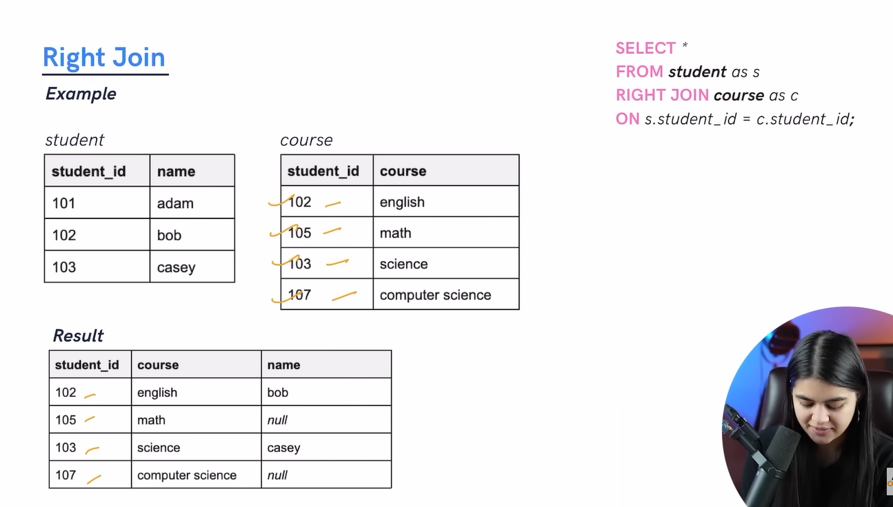

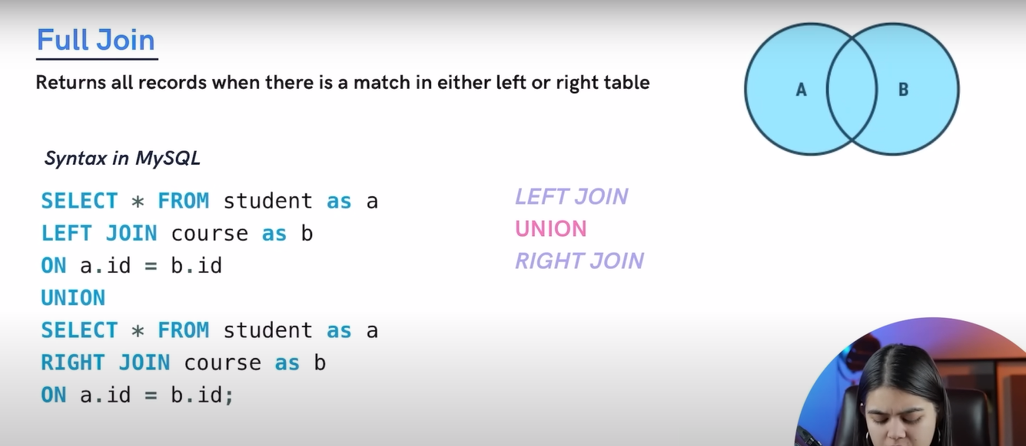

* **Full join we used when we need all data of table A and table B along with common data between table A and table B.**

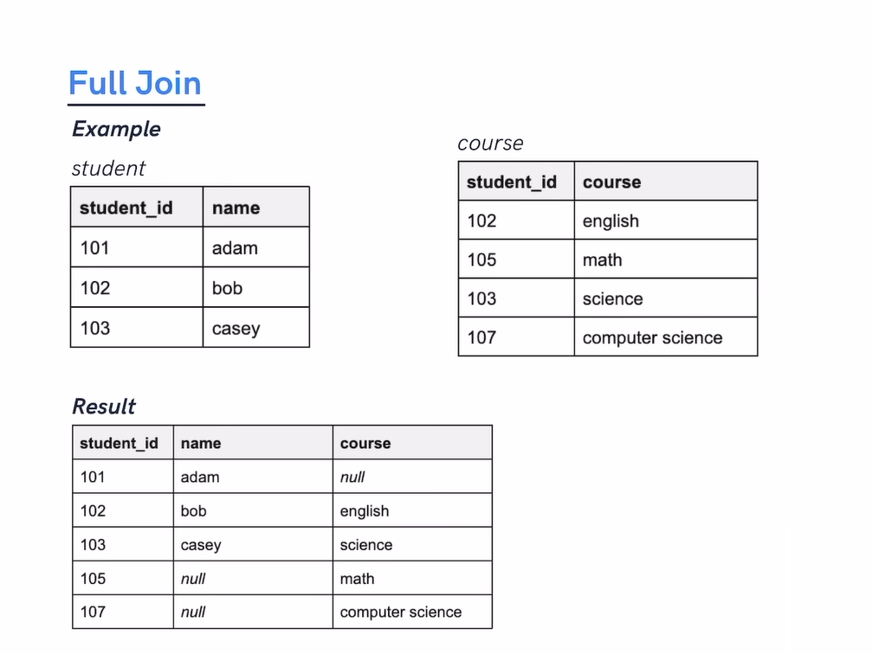

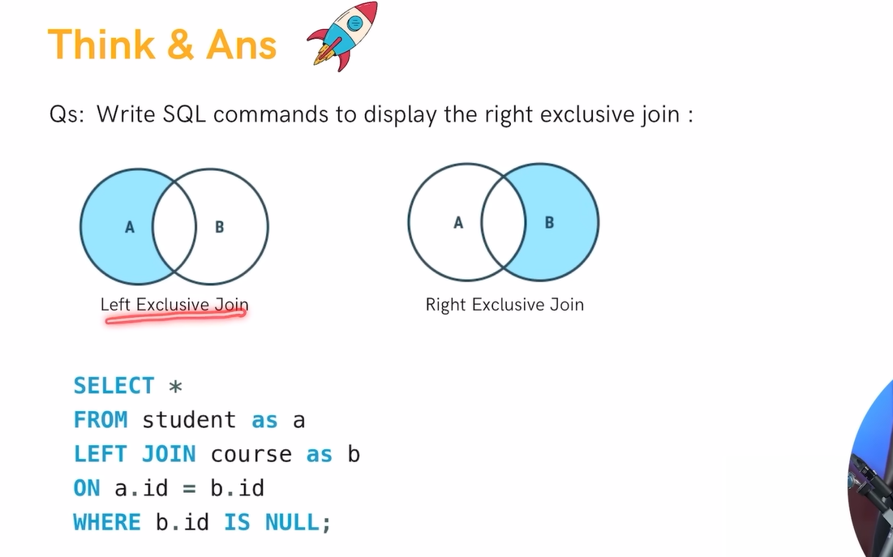

**NOTE:**

1. **Left exclusive: we want data left table A data but we don’t want data that overlapped with table B that time we can use left exclusive join**
2. **Right exclusive: we want data right table B data but we don’t want data that overlapped with table A that time we can use Right exclusive join.**

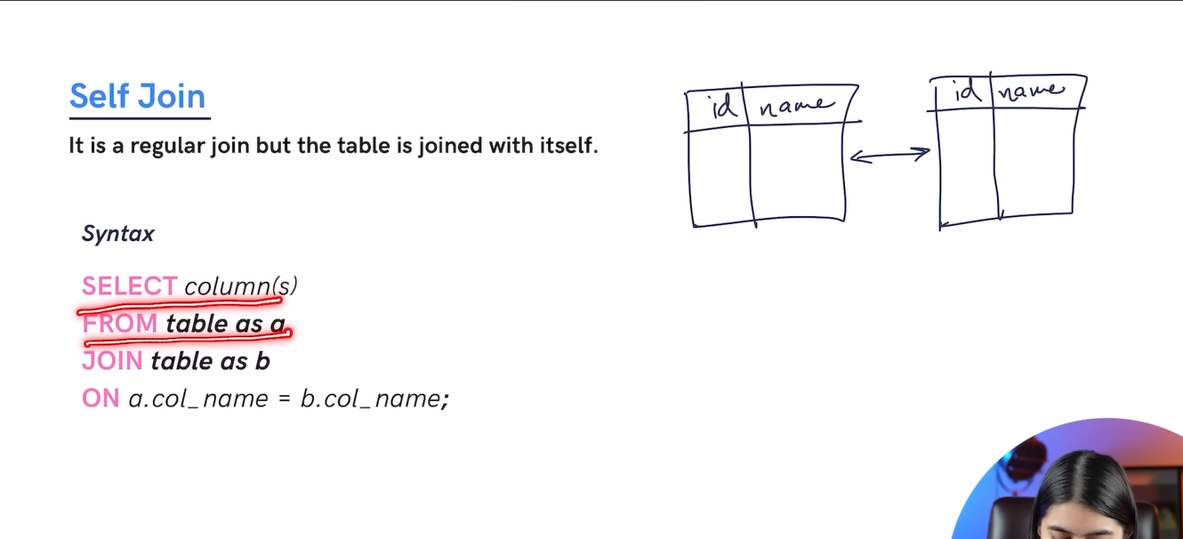

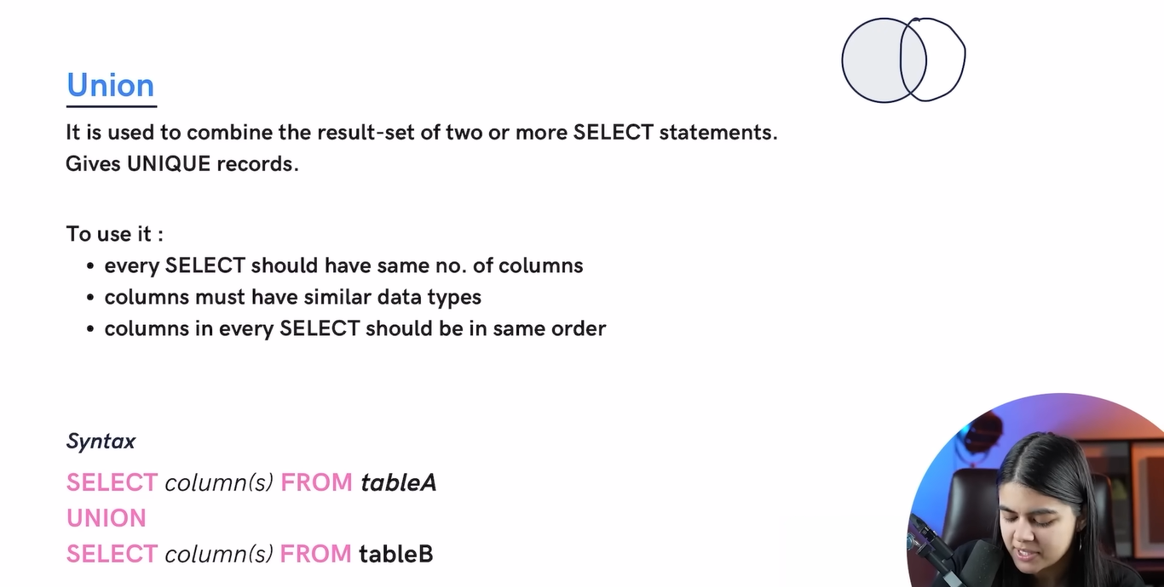

* **UNION🡪will remove duplicates and will give unique value.**
* **UNION all🡪will not remove duplicates and will give all data along with duplicate.**

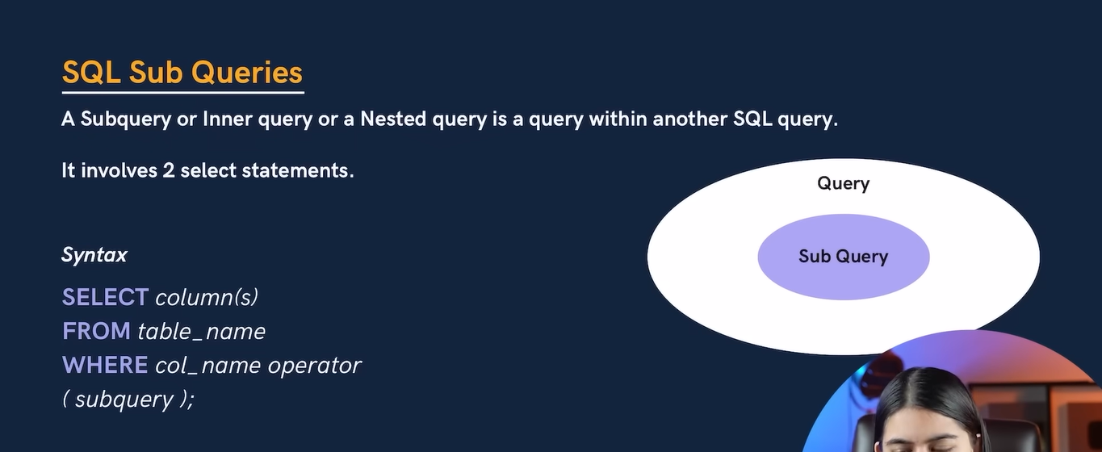

* **We can write subquery in from of select , where and from**

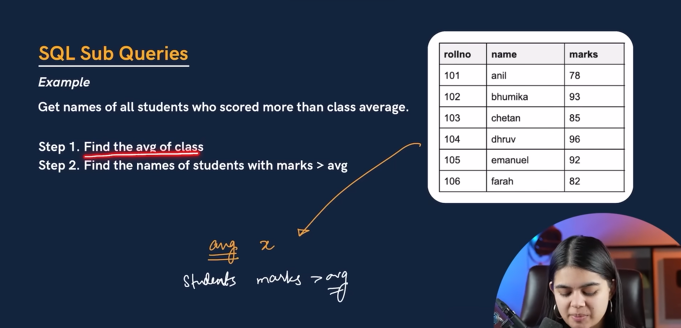

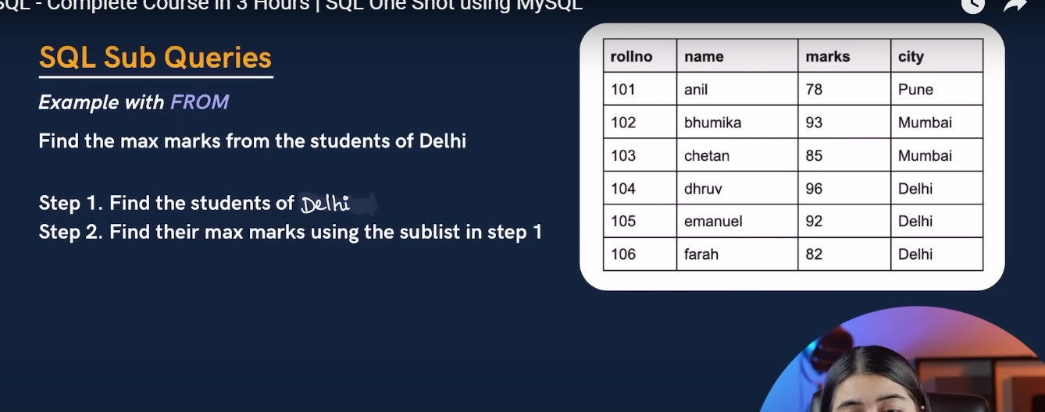

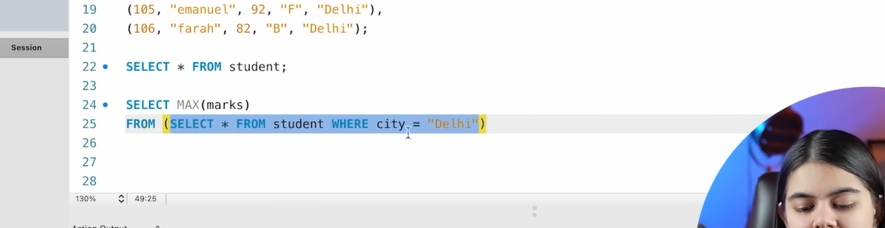

* **Sub query using select; but using select inside bracket will return single value not list as we get using select statement.**

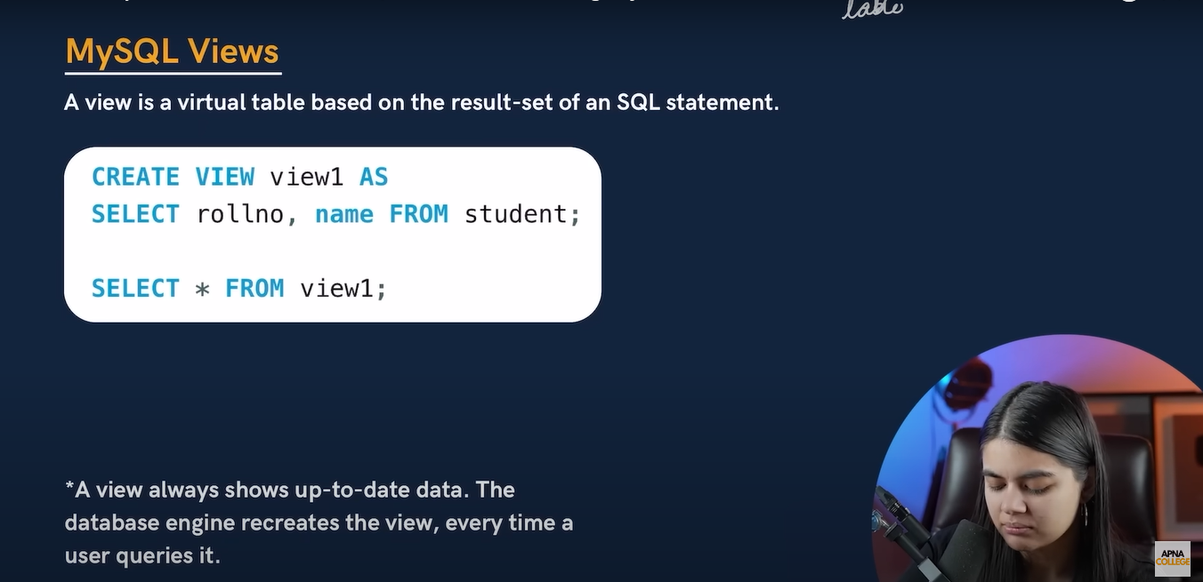

* **We can create duplicate virtual table with limited data**
* **Suppose we already have student table which have rollno,marks,name,grade and city so want to create a view table which having only data as rollno,marks and name.**

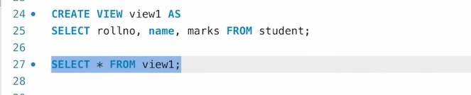

* **Then we can perform other query as we do in normal sql.**
* **But it is not real table it is virtual table.**

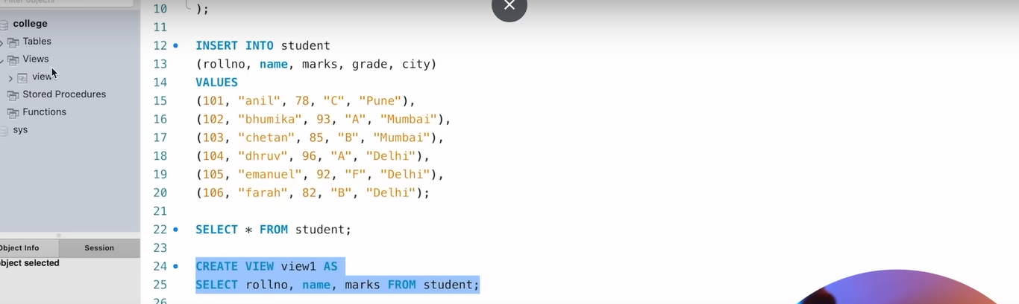

* **In sql workbench on left hand side will see tables and view so whatever view created that will reflected under view tab.**
* To fetch unique data from particular table then we can use “distinct” keyword

Example: select distinct department from workertable;

* To get particular thing/ data in uppercase/lowercase then we can use keyword upper()/lower()

Example: select upper(first_name) from worker; select lower(first_name) from worker;

* To get count of any row or something other count

Example: select count(*) first_name from worker;

* To get first 3 letter or 4 letter

Example: select substring(first_name,1,4) from worker🡪 it will print only first 4 letter of name.

* print the FIRST_NAME from the Worker table after removing white spaces from the right side.

Example : select RTRIM (first_name) from worker; -🡪 RTRIM🡪right trim. Same of left🡪LTRIM.

* Removing white spaces from the left side.

Example: select LTRIM (departement) from worker

* unique values of DEPARTMENT from the Worker table and prints its length.

Example: select distinct length(department) from worker.-->will get length of department word.

* print the FIRST_NAME from the Worker table after replacing ‘a’ with ‘A’.

Example: Select REPLACE(FIRST_NAME,'a','A') from Worker;

* FIRST_NAME and LAST_NAME from the Worker table into a single column COMPLETE_NAME. A space char should separate them.

Example: Select CONCAT(FIRST_NAME, ' ', LAST_NAME) AS 'COMPLETE_NAME' from Worker;

* FIRST_NAME Ascending and DEPARTMENT Descending.

Example : Select * from Worker order by FIRST_NAME asc,DEPARTMENT desc;

* print all details for Workers with the first names “Vipul” and “Satish” from the Worker table.

Example : Select * from Worker where FIRST_NAME in ('Vipul','Satish');

* print details of Workers with DEPARTMENT name as “Admin”.

Example: Select * from Worker where DEPARTMENT like 'Admin%';

Or

: Select * from Worker where DEPARTMENT like 'Admin%';

* print details of the Workers who joined in Feb 2021.

Example: Select * from Worker where year(JOINING_DATE) = 2021 and month(JOINING_DATE) = 2;

**Here year(), day () and month() is inbuild function of sql;**

* SQL query to clone a new table from another table.

Example:

* Joing table more than 2

Example

select *from orders

NATURAL join customer

natural join salesman🡪 here 1st joined order and customer 🡪result of this join with salesman.

* find the details of those salespeople whose names begin with ‘N’ and the fourth character is 'l'.

Example:

SELECT *

-- Specifies the table from which to retrieve the data (in this case, 'salesman').

FROM salesman

-- Filters the rows to only include those where the 'name' column:

-- - Starts with the letter 'N'.

-- - Is followed by any two characters represented by '__'.

-- - Is followed by any sequence of characters represented by '%'.

WHERE name LIKE 'N__l%';